Sabine Schmitz will race for Frikadelli Racing at Daytona

- American endurance classic is new territory for “SpeedBee”
- Cult racing team from the famous Nürburgring ready to race in the U.S. for the first time
- Frikadelli Racing one of the first outfits world-wide to race the brand-new Porsche 911 GT3 R
- Very successful Daytona test “Roar” for German team

Barweiler (D) / Daytona (USA), January 15, 2016. Frikadelli Racing is rounding up its driver line-up for the Rolex 24 at Daytona with a big surprise: Sabine Schmitz, darling of the German racing fans, is going to join the quintet that will drive the new Porsche 911 GT3 R at the great American 24-hour race at the last weekend in January.

“We’re amazed that we finally could make it happen”, beams Sabine Schmitz. For weeks it seemed that she was to miss her U.S. debut due to a business date. However, the fast German was able to reschedule the meeting and is now ready to race in Florida. Her provisional substitute, U.S. racer Connor de Phillippi from California, will therefore not drive the GT3 car for Frikadelli Racing. “I only hope that Connor will not be too disappointed. He knows his way around Daytona and would surely have done a great job for us”, says Schmitz.

“Sabine is a fixture with Frikadelli Racing“, states team owner Klaus Abbelen. He will join the “Speed Bee” along with Patrick Huisman (NL), Frank Stippler (GER) and Porsche junior works driver Sven Müller (GER) in the 500 PS Porsche. “We are absolutely excited that she has found a way to experience with us the famous race on the legendary Daytona International Speedway.”

Like Frikadelli Racing, Sabine Schmitz too is going to enter new territory. She also has no previous knowledge of the team’s racing car which is based on Porsche’s model generation 991. The team has tested the 911 GT3 R last weekend at the official Daytona testing days, the so-called “Roar”, with great success: “We were the best of the five new Porsche 911, we ended each session between P3 and P6 and set a few fastest times in mid-session which is more than we had expected”, Abbelen summarizes. “The Porsche was giving us no problems at all. We are now in a very positive mood for the race. If we manage to make little or no mistakes at all and finish the race, we might even achieve a top-5 ranking in our highly competitive category.”

Who– or what – is Frikadelli Racing?
Amongst the petrol heads that are following the popular endurance series VLN – which takes place exclusively on the Nürburgring – Frikadelli Racing has long gained cult status. One factor for this is undoubtedly “SpeedBee” Sabine Schmitz. The two-time winner of the Nürburgring 24 Hours is considered the queen of the Nordschleife. She literally grew up on the classic track and is said to have driven more than 30,000 laps there. The global TV audience knows Sabine from her quick-witted appearances in certain TV car magazines. For years now she races “the world’s fastest meatball” (English for German specialty “Frikadelle”) around the “Ring”, mostly alongside Abbelen and Huisman. The reason for the car’s unique nick-name is its livery: the Porsche’s fenders feature the products of top sponsor Abbelen, who is a successful manufacturer of “Frikadellen” and other convenience food.

The distinctive livery of the 911 GT3 R, however, should not distract from the fact that Frikadelli Racing is a highly professional racing outfit. In 2010, Klaus Abbelen’s team moved to a state-of-the-art workshop with nearly 20,000 square feet floor space with an own engine test bench. Here, the team’s technicians prepare up to five racing cars at a time for their outings on the Nordschleife.

Frikadelli Racing is one of the first racing teams world-wide to be entrusted by Porsche with one of the newly developed 911 GT3 R.

Note to editors: You will find news of Frikadelli Racing on Twitter: @Frikadelli_R

Images and captions:

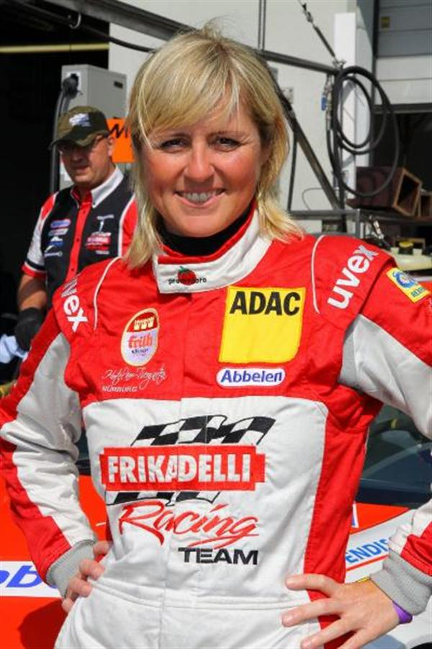

“Speed Bee” will drive for Frikadelli Racing at the Daytona 24 hours: iconic Nürburgring racer Sabine Schmitz.

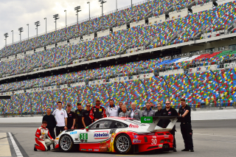

They have taken the leap: at the Daytona International Speedway, Frikadelli Racing is entering new territory.

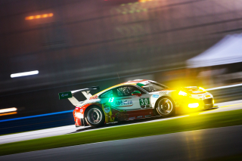

Successful first outing: Frikadelli Racing ended up as fastest Porsche team at the three-day testing at Daytona last weekend.

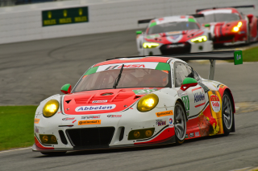

The team’s new Porsche 911 GT3 R – based on the model generation 991 and fresh out of the box – was running absolutely faultless at the “Roar before 24”.

