Frikadelli Racing looking forward to one of the team’s biggest challenges ever – the Daytona 24

- Renowned Nürburgring Nordschleife racers to start for the first time at the classic Rolex 24
- Five-strong driver line-up: “Speed Bee” Sabine Schmitz, team owner Klaus Abbelen, Patrick Huisman, Frank Stippler and Porsche junior Sven Müller
- First competitive outing for new Frikadelli-Porsche 911 GT3 R with more than 500 PS
- Team in a positive mood for 24-hour race after successful testing at the “Roar before the 24”

Barweiler (D) / Daytona (USA), January 26, 2016. Frikadelli Racing is experiencing one of the most exciting weeks in the team’s history: Next week-end, the racing team from Barweiler at the world-famous Nürburgring will contest the Daytona 24 Hours for the first time ever. The crew around team owner Klaus Abbelen and “Queen of the Nordschleife” Sabine Schmitz is racing one of the first 911 GT3 R based on the model generation 991 that Porsche delivered to a customer team. Abbelen and Schmitz will take turns with experienced Daytona racers Patrick Huisman (NL) and Frank Stippler (D) as well as Porsche junior driver Sven Müller at the 911’s steering wheel.

The “Rolex 24” is arguably North America’s most famous endurance race. It ranks at eyelevel with the Le Mans 24 Hours and the 24 hour-race at the Nürburgring. The Daytona classic is held on a 5.73 kilometer track that combines the Daytona International Speedway’s banked curves known from the “Daytona 500” with a twisty infield section. In Florida, Frikadelli Racing is celebrating its international debut. Abbelen, Huisman and Müller already took part in the three testing around two weeks ago when the new Porsche 911 GT3 R’s strong performance raised a few eyebrows.

The event will go underway this Thursday with the first free practice at 9:25 a.m. (3.25 p.m. MEZ). The second session will be under way from 1:20 p.m. (7:20 p.m. MEZ). The 15-minute Qualifying starts at 4:00 p.m. (10:00 p.m. MEZ) night-time practice is scheduled between 6:30 and 8:00 p.m. (Friday 0:30 to 2:00 a.m. MEZ). Friday morning will see the fourth practice session from 10:25 to 11:25 a.m. (4:25 to 5:25 p.m. MEZ). The actual race will start on Saturday at 2:40 p.m. (8:40 p.m. MEZ).

Quotes from the run-up to the Daytona 24

Klaus Abbelen (Germany, team owner and driver): “I’ve been dreaming of competing in the Daytona 24 for 15 years. Now the time has come to turn the dream into reality. We have been working on the project since Le Mans 2015. It was there that I met Scole Scrogham who supports our team a great deal. I think that we have made our homework well. Now we are looking forward to a fantastic race.”

Sabine Schmitz (Germany, driver): “I’ve never before been to Daytona and I even had to skip the official testing due to business obligations. I tried to learn the track as best as possible by video and simulations and have extensively analysed our data. Now I hope that the guys will give me a little more time in the cockpit during the practice sessions.”

Sven Müller (Germany, driver from the Porsche junior squad): “I am just returning from the 24-hour race in Dubai where we won the Cup category so you might say I’m on a roll. Here in Daytona it will be vital to go the distance without accidents or mechanical problems. This will certainly be one the keys to success.”

Patrick Huisman (Netherlands, driver): “We already saw in Daytona testing that the new Porsche 911 GT3 R is a big step forward. Te car is real fun to drive; it reacts well to changes in the mechanical and aerodynamical set-up. Thanks to a longer wheel-base compared to its predecessor it is also easier to drive and more precise. I am absolutely delighted to and looking very much forward to what will be my eleventh start at Daytona.”

Frank Stippler (Germany, driver): „The combination of the road-course type infield and the speedway passages with the oval’s banked curves makes Daytona very special. In Europe there is no track with a similar layout. We also have to watch the faster cars from the prototype category. When we race on the Nordschleife, we usually keep a watch on the cars in front, because our GT3 is one of the fastest cars there. The whole Frikadelli line-up has to adapt to looking into the mirrors quite often.“

Who – or what – is Frikadelli Racing?
Amongst the petrol heads that are following the popular endurance series VLN – which takes place exclusively on the Nürburgring – Frikadelli Racing has long gained cult status. One factor for this is undoubtedly “SpeedBee” Sabine Schmitz. The two-time winner of the Nürburgring 24 Hours is considered the queen of the Nordschleife. She literally grew up on the classic track and is said to have driven more than 30,000 laps there. The global TV audience knows Sabine from her quick-witted appearances in certain TV car magazines. For years now she races “the world’s fastest meatball” (English for German specialty “Frikadelle”) around the “Ring”, mostly alongside Abbelen and Huisman. The reason for the car’s unique nick-name is its livery: the Porsche’s fenders feature the products of top sponsor Abbelen, who is a successful manufacturer of “Frikadellen” and other convenience food.

The distinctive livery of the 911 GT3 R, however, should not distract from the fact that Frikadelli Racing is a highly professional racing outfit. In 2010, Klaus Abbelen’s team moved to a state-of-the-art workshop with nearly 20,000 square feet floor space with an own engine test bench. Here, the team’s technicians prepare up to five racing cars at a time for their outings on the Nordschleife.

Frikadelli Racing is one of the first racing teams world-wide to be entrusted by Porsche with one of the newly developed 911 GT3 R.

Note to editors: You will find news of Frikadelli Racing on Twitter: @Frikadelli_R

Images and captions:

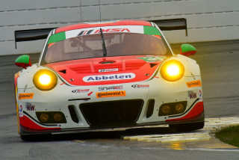

First race away from home: Frikadelli Racing is looking forward to the 24-hour adventure in Daytona.
Photo credit: Frikadelli/Michael Stahlschmidt

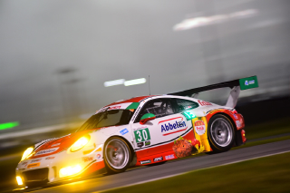

Competitive debut at the Daytona 24: Frikadelli Racing is one of the first customer teams to race the new Porsche 911 GT3 R.
Photo credit: Frikadelli/Michael Stahlschmidt

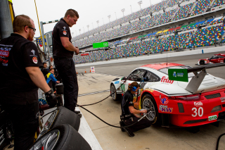

A new environment: The IMSA pit stop procedures are another aspect that Frikadelli Racing is adapting to.
Photo credit: Frikadelli/Michael Stahlschmidt

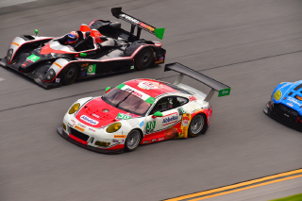

Adding to the challenge: On its German home track the Frikadelli Porsche GT3 ranks amongst the top dogs; in Daytona the crew will have to watch out for the faster prototypes.
Photo credit: Frikadelli/Michael Stahlschmidt

